**POLITICAL JUGGERNAUTS : A QUANTITATIVE ANALYSIS OF CANDIDATES IN THE 2019 LOK SABHA ELECTIONS**

INTRODUCTION:

The Lok Sabha is composed of representatives of people chosen by direct election on the basis of Universal Adult Suffrage. The Constitution of India allows for a maximum of 550 members in the House, with 530 members representing the States and 20 representing the Union Territories. The 17th Lok Sabha was formed by the members elected in the 2019 Indian general election. Elections, all across India, were conducted in seven phases from 11 April 2019 to 19 May 2019 by the Election Commission of India.

The Bharatiya Janata Party received 37.36% of the vote, the highest vote share by a political party since the 1989 general election, and won 303 seats, further increasing its substantial majority. In addition, the BJP-led National Democratic Alliance (NDA) won 353 seats.

**PROBLEM DEFINITION:**

EMPATHY MAP

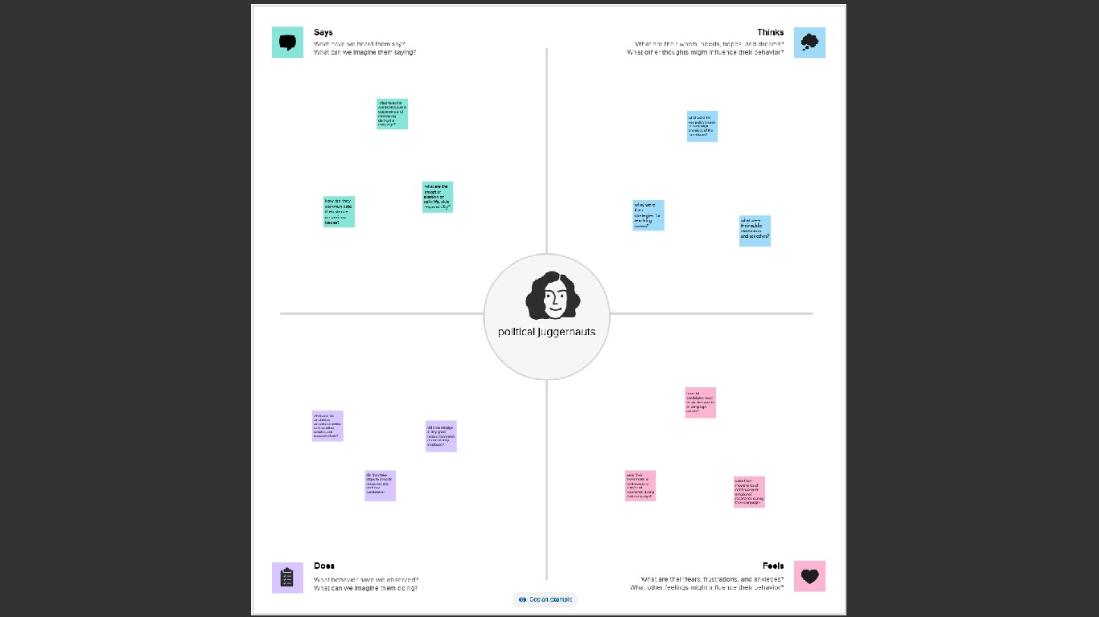

BRAINSTROMING:

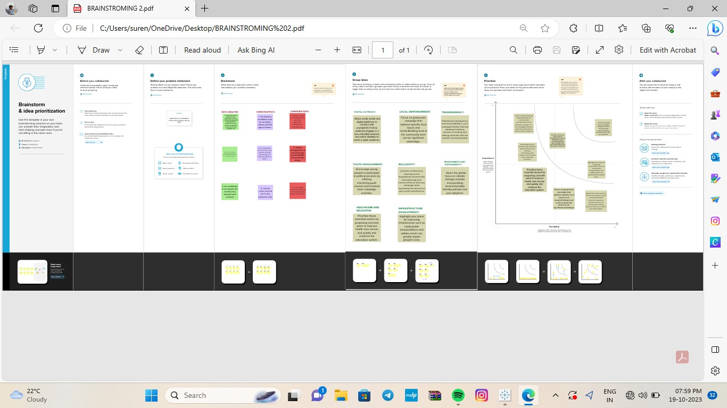

**RESULTS:**

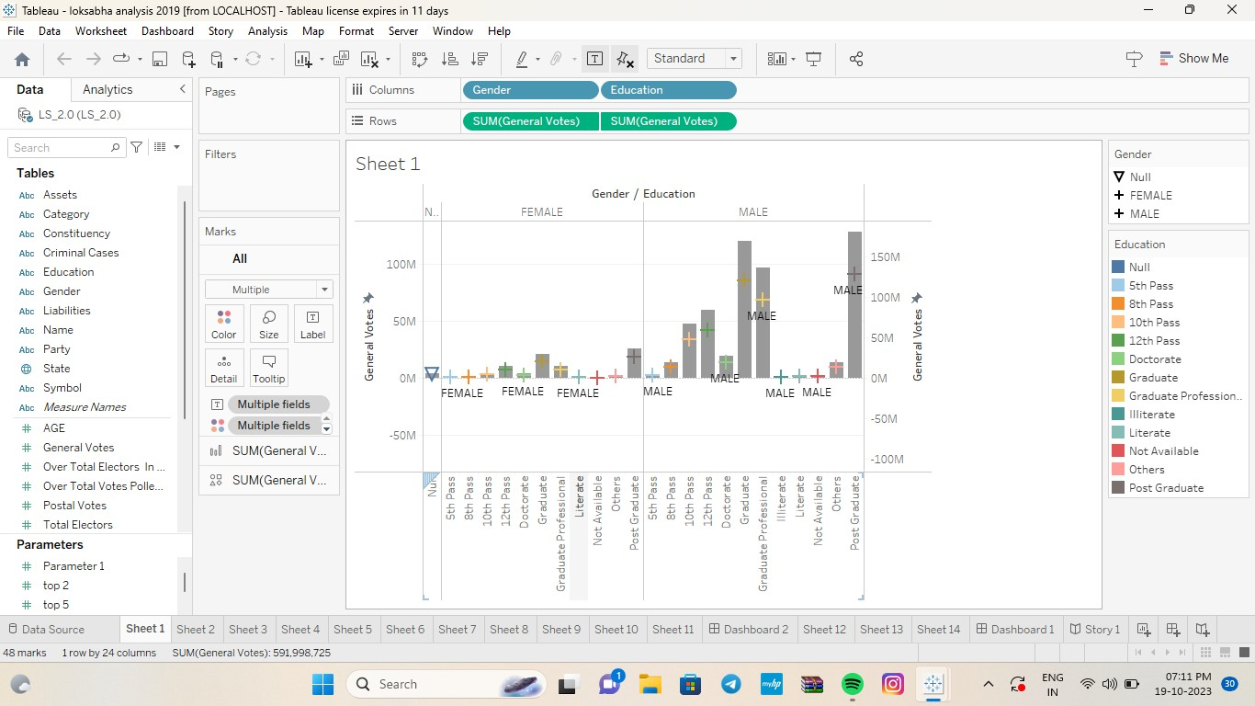

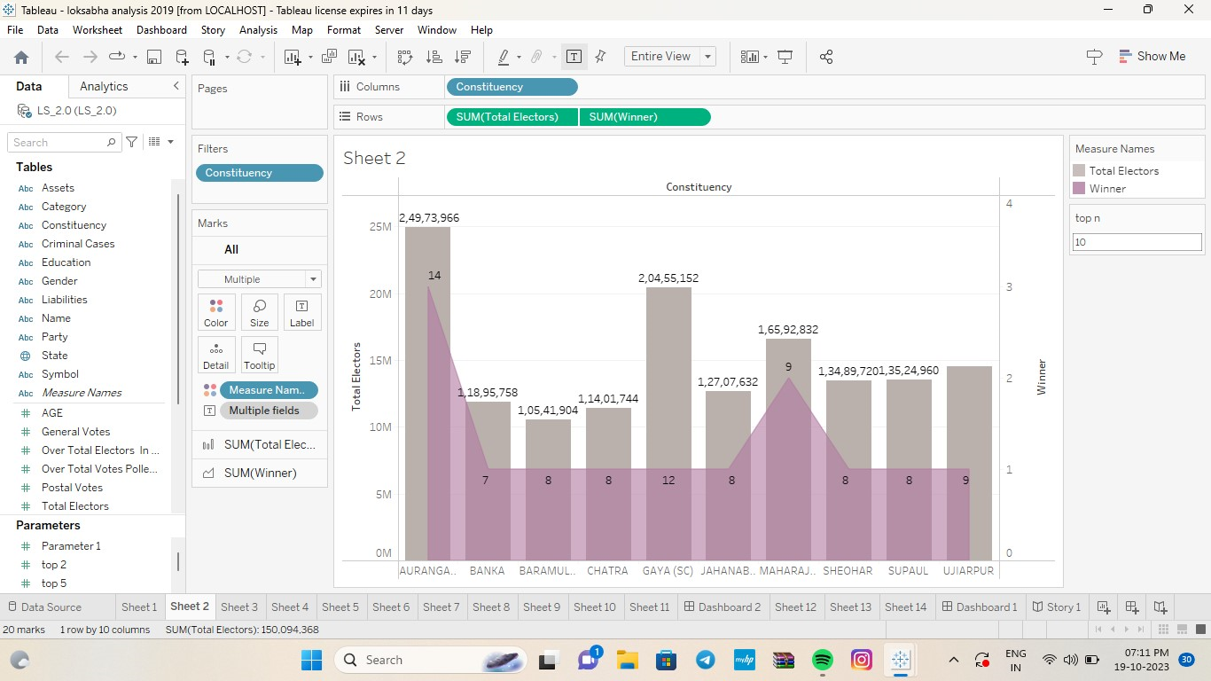

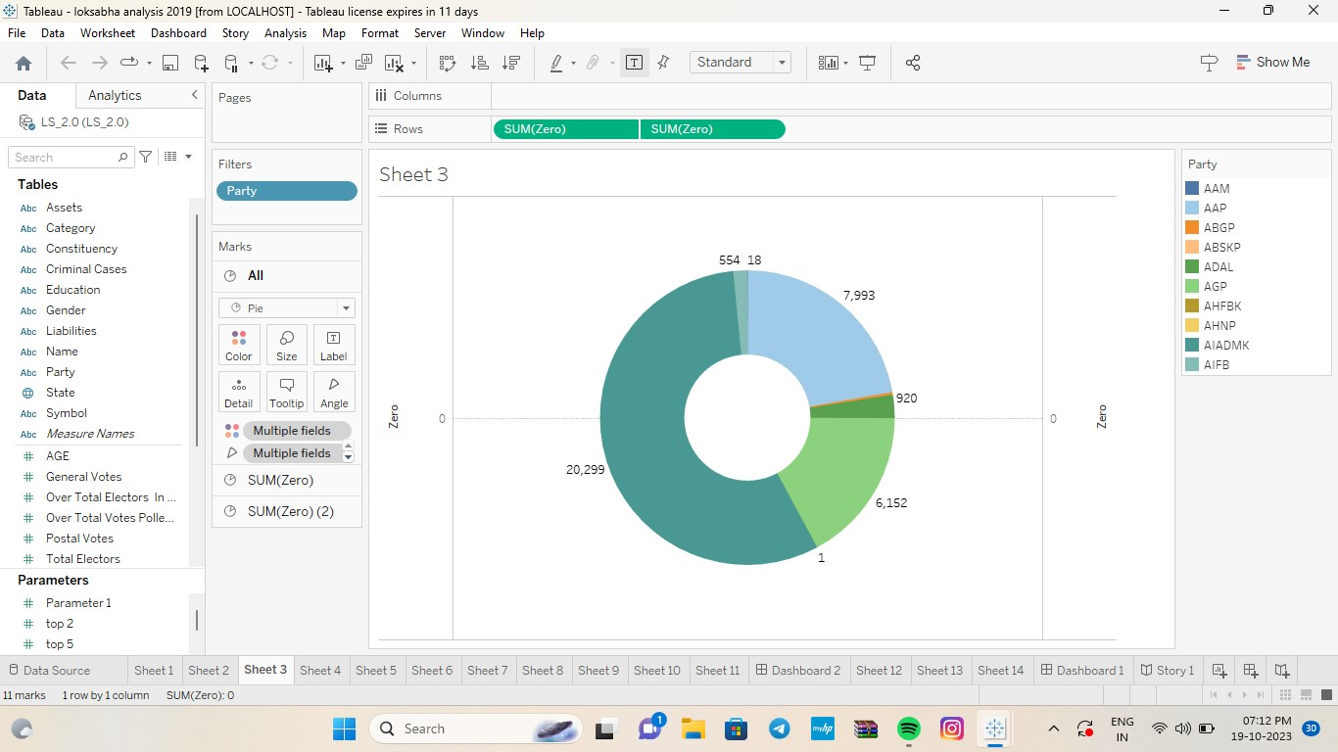

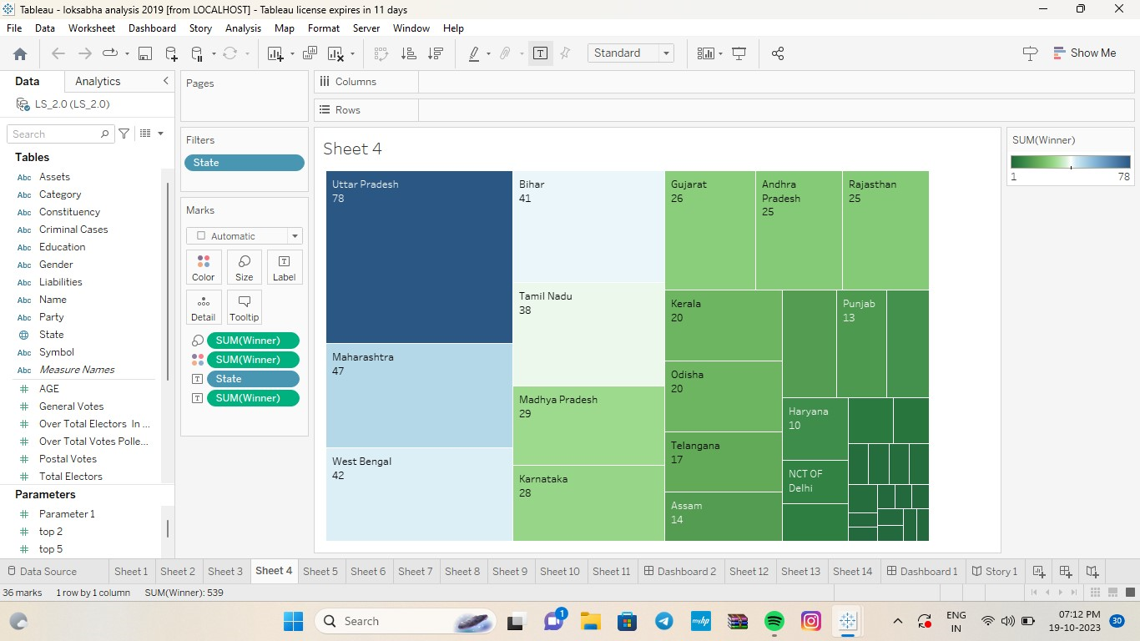

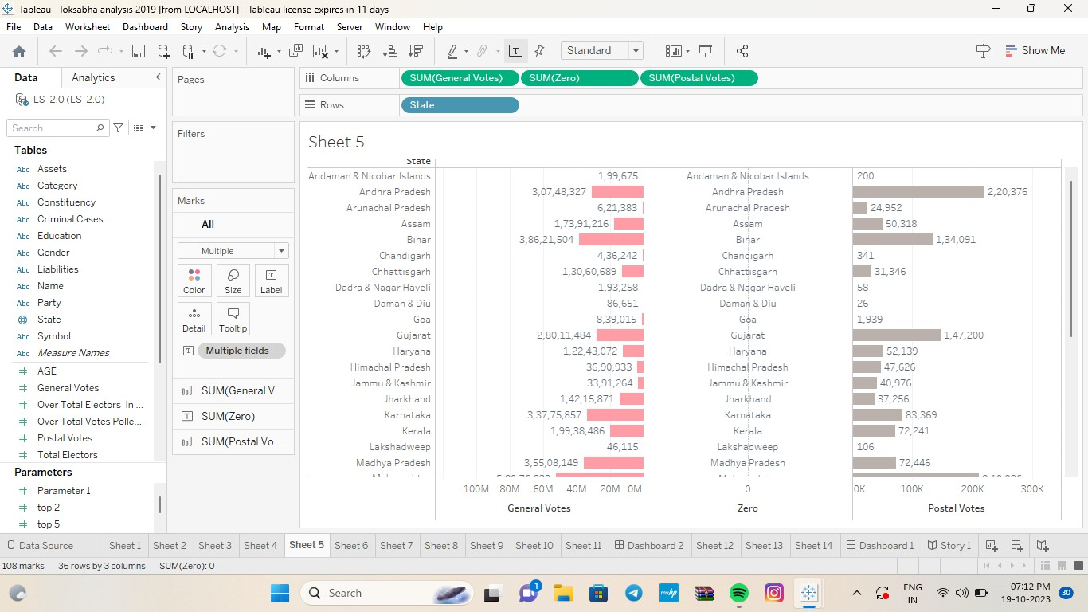

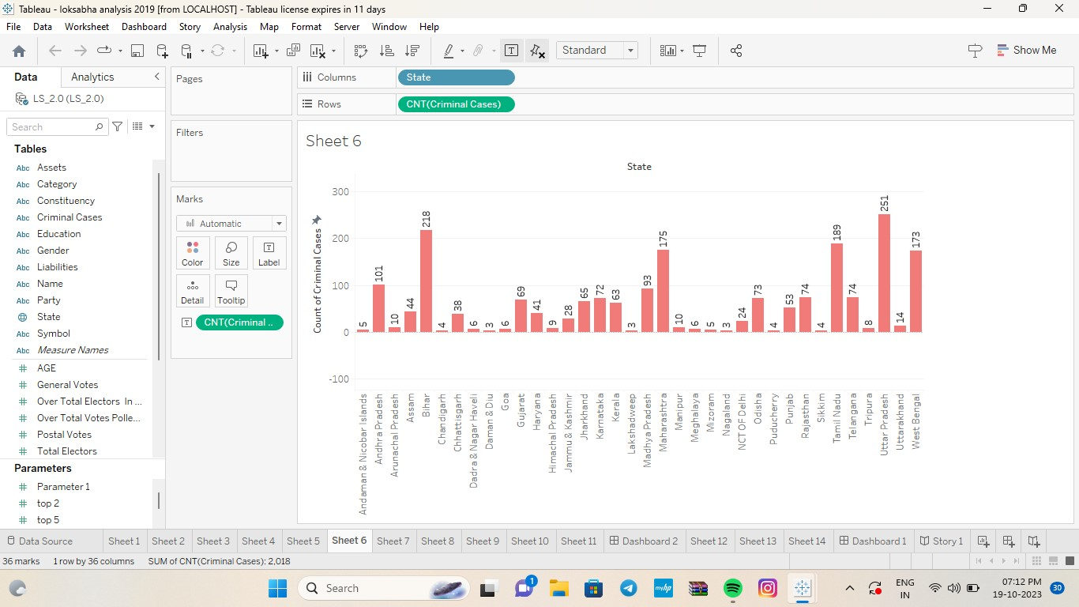

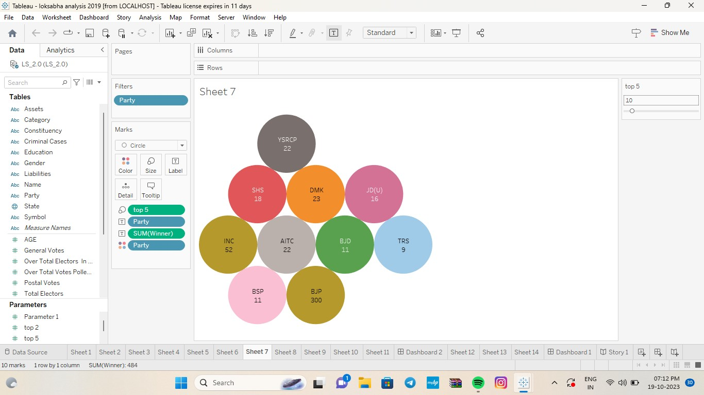

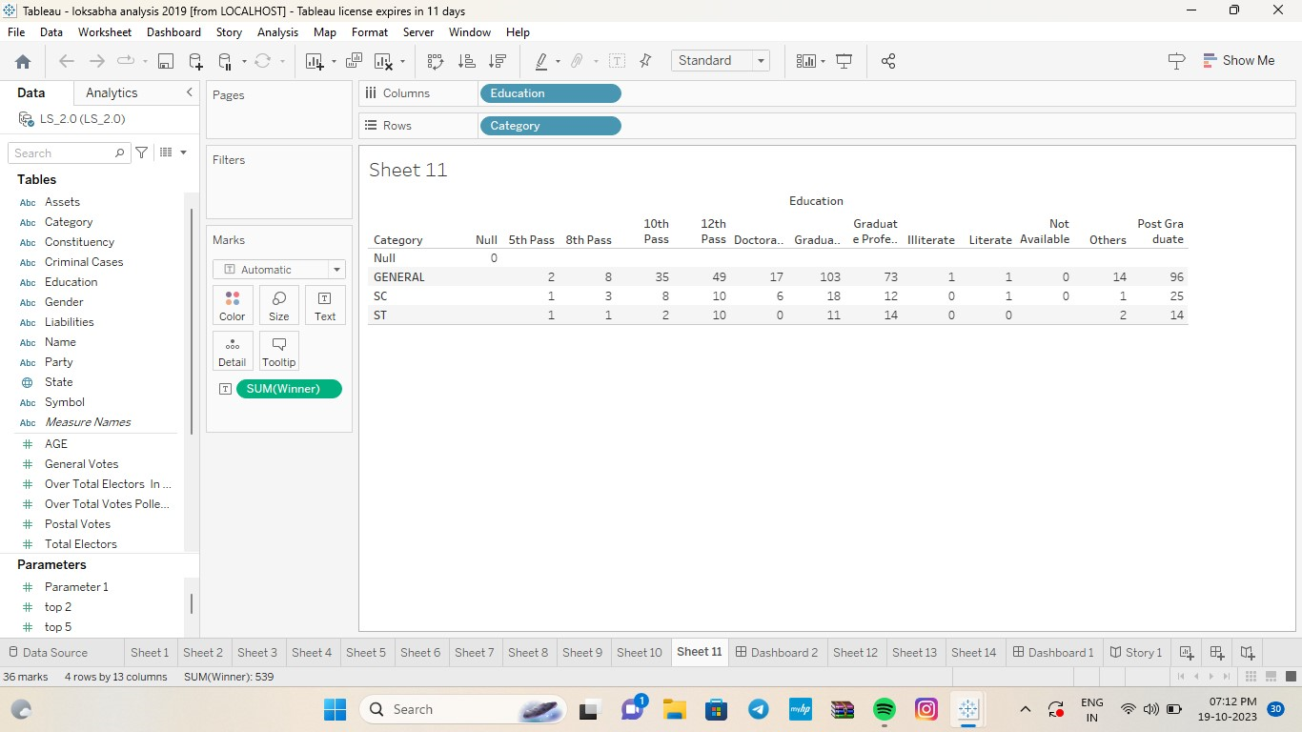

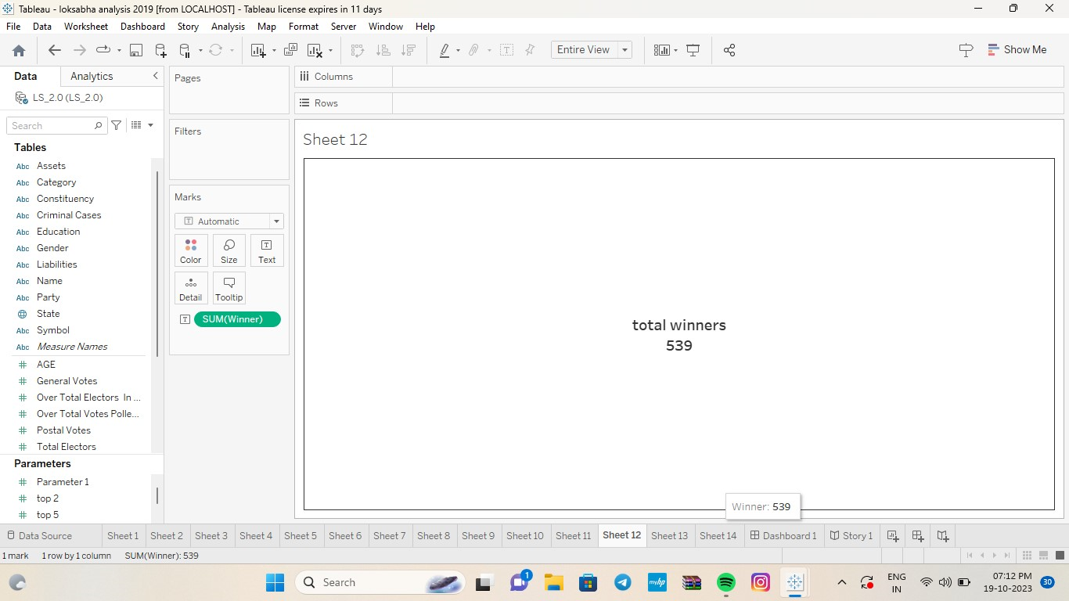





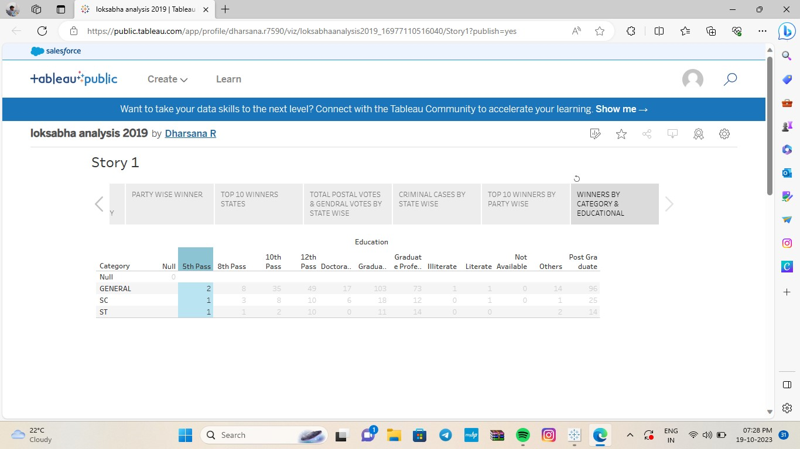

**CANDIDATES:**

Altogether 8,039 candidates were in the fray for 542 parliamentary constituencies, i.e., 14.8 candidates per constituency on an average, according to PRS India, an NGO.

About 40% of the candidates fielded by Prime Minister Narendra Modi's Bharatiya Janata Party had a criminal case against them. Key opposition party Congress was not far behind with 39% of the candidates with criminal charges, according to Association of Democratic Reforms analysis

General elections were held in India in seven phases from 11 April to 19 May 2019 to elect the members of the 17th Lok Sabha. Votes were counted and the result was declared on 23 May. The election resulted in a landslide victory for the BJP which won 303 seats and formed the government.

**CONCLUSION :**

Notwithstanding these differences, the BJP’s remarkable victory appears to have been based on a broad-based Hindu social alliance cutting across caste and class.

In his 1970 book, Politics in India, the renowned political scientist Rajni Kothari had coined the term ‘Congress system’ to describe the party’s ability to assimilate diverse social groups and even dissidents within its fold.

We may be witnessing the rise of a new ‘BJP system’ in Indian politics today.